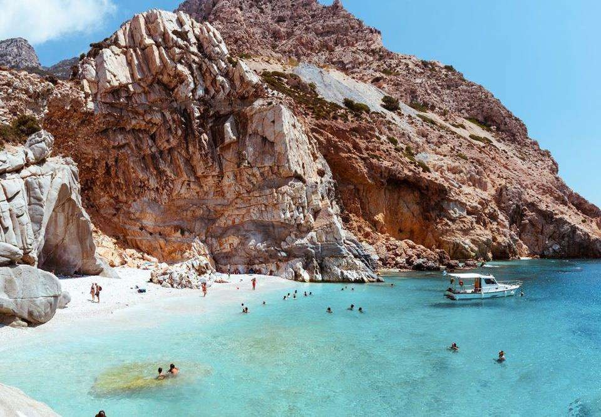
September 27, 2021

UNEXPLORED GREEK ISLANDS 2022
ABOARD THE 17-CABIN M/Y CALLISTO
JULY & SEPTEMBER 2022 | 8-day cruises Friday sailings | From Athens to Athens, Greece
A cruise voyage unraveling the most authentic Cycladic and Dodecanese islands of Greece. Discover unknown gems with rich history, incomparable light, translucent water, and heavenly beaches.
Highlights include:
September 27, 2021
Cape Sounion · Ikaria · Patmos · Lipsi · Kalymnos · Amorgos · Koufonisia · Iraklia ·Serifos

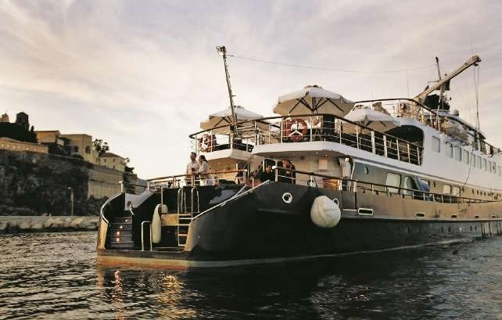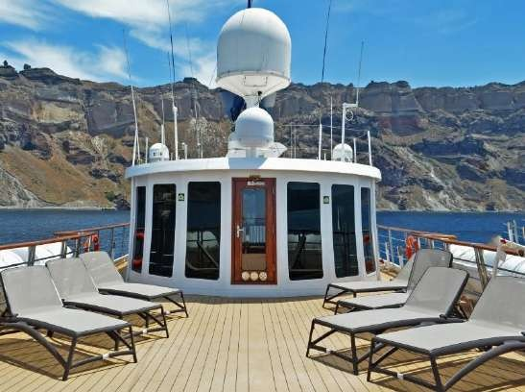
September 27, 2021
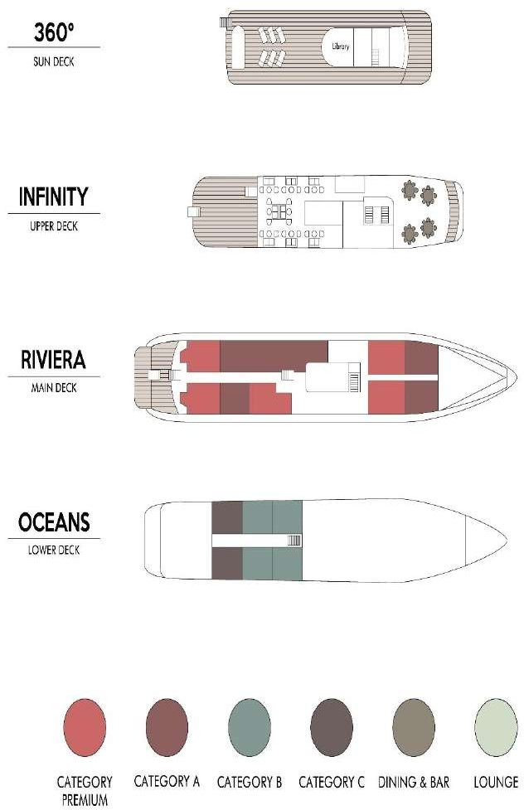

M/Y CALLISTO
MEGA YACHT

The Callisto is a 52 m /170 ft Motor Yacht which complies with the latest SOLAS regulations for International Voyages. Her state-of-the-art twin stabilizers allow for safe and comfortable cruising.
GENERAL INFORMATION:
Length: 52 m (170 ft)
Launch Year: 2000 | Fully refitted: 2015 Cabins: 17
Capacity: 34 passengers
Crew: 17

The elegant Motor Yacht Callisto joined the VARIETY CRUISES fleet in 2015 and is true to her name: Elegant, classic. She was fully refit / rebuilt in 2000 and was thoroughly renovated in 2015-16.
This classy Motor Yacht has performed several Atlantic Ocean crossings and has also sailed along the most interesting coastal sites of Europe, North and West Africa. The M/Y Callisto is of the “boutique” category of cruiser, and offers the highest standard of accommodation, comfort and safety.
Service on board is provided by your Captain, the Cruise Coordinator and your experienced Marine and Hotel crew members.

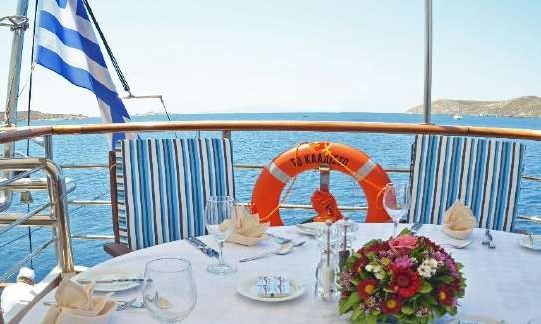
M/Y CALLISTO
September 27, 2021

MEGA YACHT

CABIN SPECIFICATIONS:
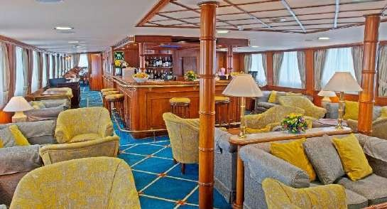
The Callisto offers 17 finely appointed exterior cabins located on the Lower and the Main decks. All cabins are comfortably arranged and beautifully furnished with wooden furniture and light fabrics. All have marble-appointed en suite bathrooms with showers and are equipped with windows (Main deck cabins) and portholes (Lower deck cabins). All cabins have individually controlled A/C and fitted with flat-screen TV, telephone (for internal use), hairdryers, mini-fridge, central music, public address system and safe boxes. Four Main deck cabins –bow section- offer 1 double bed while all other cabins in the Lower and Main decks are equipped with twin beds.

LIFE ON BOARD
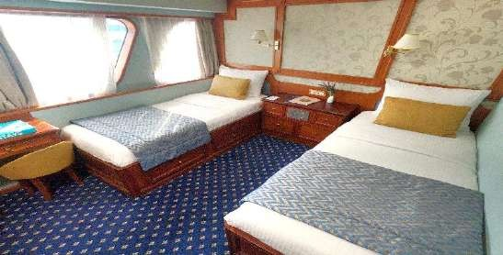
The yacht’s public areas are cozy and generous, decorated with rich fabrics, handsome woodwork, gleaming brass, antiques and fine works of art. During the day, life on board centers around the indoor and outdoor areas including the Upper deck Indoor and Outdoor lounge/bar and dining areas as well as the cozy Library located on the Sun Deck.

MAIN LOUNGE
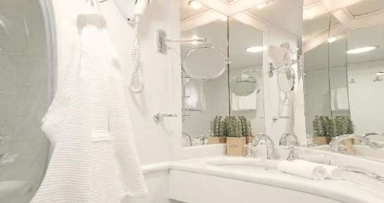
The lounge/bar and dining room on the Upper deck are connected by the gallery, displaying exquisite art and adding to the overall feeling of elegance and style. In the evening you can relax in the ship’s lounge, enjoy a drink overlooking the stars or relax with a book in the library with its wraparound windows. The spacious lounge and bar area on the Upper Deck is surrounded by large picture windows and opens onto the Outdoor Dining area.

DINING ROOM
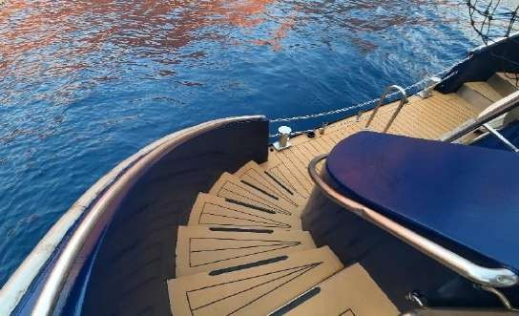
Located on the Upper deck, the dining room seats all passengers in a single, unassigned seating and allows for spectacular views around, while dining in an elegant environment. Meals can be also served “al fresco” on the Upper Deck’s outdoor Deck, depending on weather conditions. Food is served at the table or displayed on the state of the art hot & cold buffet which also includes an “a la minute cooking” section.

SUN DECK
The yacht features a broad Sun Deck for sunbathing and the swimming platform on Callisto’s stern enables you to swim off the ship when in sheltered bays. Sun loungers are available to sunbathe in total comfort. In the evening you can relax in the ship’s lounge, enjoy a drink overlooking the stars or relax with a book in the library with its wraparound windows.

NEW! LIMITED COLLECTION VOYAGES BY VARIETY CRUISES UNEXPLORED GREEK ISLANDS 2022
FRIDAY DEPARTURE · 7-NIGHTS/8-DAYS · FROM ATHENS TO ATHENS, GREECE
DAY 1  FRI | ATHENS- CAPE SOUNION | Embarkation 14:00-15:00. Set sail for nearby Cape Sounion. Sunset cocktails and welcome dinner al fresco under the ancient Greek temple of Poseidon. Overnight at sea towards the island of Ikaria.
DAY 2  SAT | IKARIA☽  GREECE | In the morning, we stop for a refreshing swim at the Seychelles beach, accessible best by yacht. Enjoy the translucent blue waters and bright white pebbles covering the sea bottom. BBQ lunch on board and our ship docks in Ikaria's quaint port. Ikaria is an island-phenomenon unlike anywhere else in Greece or in the world. People here live much longer than the population on other islands and mainland. In fact, people here live on average 10 years longer than those in the rest of Europe and the Americas. Join our tour discovering authentic villages that march to a different drummer, enjoy a hike in wild landscapes followed by a dip in one of the eight natural thermal springs or join a cooking class in a family’s country home kitchen, and garden in an ancient village for a personalized experience cooking and learning about life and the secret to the inhabitants’ famed longevity, the Blue Zone Greek Island. Afternoon at leisure, or at one of the village traditional fairs.
DAY 3  SUN | PATMOS- LIPSI ☽ GREECE | Early morning sailing and arrival in Patmos, an island revelation with a touch of divine. Surrender yourself to the mysticism and tranquility of the island of the Apocalypse. Morning discovery of two UNESCO World Heritage Sites, the Grotto and Monastery of St. John and the historic center of the medieval town of Chora, filled with grandeur and serenity. Small and secluded yet spectacular all the same, Patmos is the “Jerusalem of the Aegean”. Afternoon sailing to Lipsi island, a time capsule of authenticity in the Dodecanese. Lunch al fresco and swim stop in one of the glittering necklaces of 24 islets await, protected by the Natura 2000 network making an ideal refugee for the shy Mediterranean Monk seal. While in Lipsi we invite you to taste the famous Aposperitis red Lipsi wine (on board treat). Evening at leisure to enjoy the setting of the local harbour at sunset, and a seaside dinner with home-cooked traditional recipes made of local produce. Overnight in Lipsi.
DAY 4  MON | KALYMNOS  ☽  GREECE | Early morning sailing to Kalymnos with a swimstop on the way. Kalymnos is a hidden gem island for those who crave simplicity and authenticity. Home of the famous sponge divers, this island in the Dodecanese is ideal for modern day adventurers with 1,300 market hiking routes to be explored. Join our tour to engage with the locals harvesting sponges and producing about 30,000 sponges annually, witness the numerous species of sponge and the various stages they go through before reaching the market. Afternoon at leisure to enjoy a hike or marvel the Esperidon fjord, perhaps the most beautiful fjord in Greece. Overnight in Kalymnos quaint port.
DAY 5  TUE | LEVITHA- AMORGOS☽ GREECE | The ship sails towards the white and blue Cyclades. Enjoy a stop at Levitha island, inhabited by a family of four, raising animals. In the summer, the family also runs a small but spotless restaurant for the visiting yachts. They grill to perfection fresh fish and meat. Enjoy a hike on one of the island's goat paths. On top of the island there is an abandoned World War II Italian outpost. Midday sailing to Amorgos, the island of Luc Besson's "Big Blue". Mellowed with traditions, firewater and laid-back villages, Amorgos will make you forget the 20th century, never mind the 21st. Enjoy an afternoon with locals learning how to make the island's famous "Psimeni Raki", a local homemade liquor with the flavor of honey and clove made since ancient times on Amorgos. Evening at leisure to enjoy the breathtaking medieval capital, 400m above sea level. Overnight in Amorgo's quaint port of Katapola.
DAY 6  WED | AMORGOS- KOUFONISIA  -IRAKLIA☽  GREECE | Our early morning discovery will take us to the impressive monastery of Chozoviotissa built in 1088 inside the rocky cliffs of the mountain. We will visit monks’ cells which are open to visitors and contain important heirlooms and artifacts. We are offered a glass of Psimeni Raki and a local sweet while we enjoy magnificent views of the Aegean. Return on board for a short sail to the Small Cyclades: enjoy a swim in Koufonisia, take out the ship's Kayaks and Paddle boards to explore sea caves only accessible by yachts. Afternoon scenic cruise around the nearby island of Schinoussa before we reach Iraklia, a tiny hidden island gem in the midst of the Aegean. Part of the Natura 2000 network of natural habitats, it enchants with the superb views offered by its mountainous footpaths, the variety of its coastline and its own, unique sights. There is no supermarket on the island, and deliveries come by ferry from the nearby island of Naxos. Evening at leisure to enjoy the true laid-back Greek island life. Overnight in port.
DAY 7  THU | SERIFOS  GREECE | In the morning we reach Serifos, a quintessentially Cycladic Island of brilliant light, clear water, and steadfast traditions. Enjoy a swim at one the island's remote beaches accessible best by small ship. Barbecue lunch on board, followed by an afternoon stroll to explore the island's picture-perfect "Hora" castle-village. Join our tour to a local winery offering unobstructed views to the Aegean or get creative in the island's ceramic studio where you can master the basics of pottery and bring as gifts back home. Farewell dinner reminiscing all the hidden gems of Greece. Midnight sailing back to Athens.
DAY 8  FRI | ATHENS  GREECE | Disembarkation at 9:00 am after breakfast.
☽OVERNIGHT IN PORT
Itineraries can be changed at the discretion of Variety Cruises and of the Vessel's Captain in case of adverse weather conditions - winds of 6/7 beaufort or more depending on the vessel- on port authorities not allowing a vessel to leave port or in case of other extraordinary conditions. Such itinerary changes do not automatically entitle passengers to any refunds, but Variety Cruises guarantees that passengers are disembarked at the advertised port of disembarkation on time for their flights.

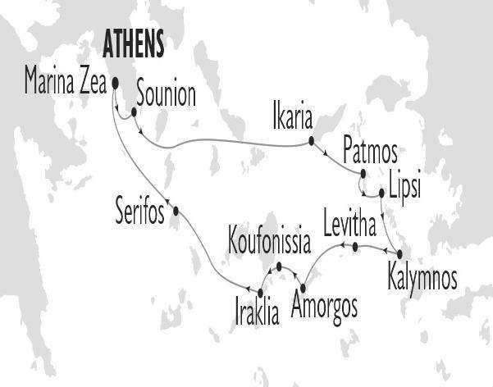

UNEXPLORED GREEK ISLANDS 2022 – on board M/Y CALLISTO
SAILING DATES
FROM ATHENS/MARINA ZEA, Greece  Friday Sailings | 01, 15 July 2022  16 Sep 2022

